Philadelphia University  Lecturer: Mr. Abdalrahman Obidat  Coordinator: Mr. Abdalrahman Obidat  Internal Examiner: Dr. Mohammad Taye |  | Faculty of IT  Department of SE  Examination Paper

Computer Aided Software Engineering (721445+722489) Section 1 Final Exam

Time: 2 hours

Marking schema && Answer Key

I. Basic Notions
Objectives: The aim of the questions in this part is to evaluate the required minimal student knowledge and skills. Answers in the pass category represent the minimum acceptable standard.

Question 1: Knowing that CASE is stand for Computer Aided Software engineering, answer the following: (3.5 marks)
- What is CASE? —2 marks.

- Give three of CASE tools Taxonomy? —1.5 marks

—2 marks

Software systems that are intended to provide automated support for software process activities.

—1.5 marks
(Any three)
Give three of CASE tools Taxonomy? —1.5 marks
Project management
Support
Analysis and Design
Programming
Integration and Testing
Prototyping
Maintenance)

Question 2: In Visual Paradigm case tool: (3.5 marks)
A) Give three Features for this case tool. —1.5 marks

B) For what you can use Animacian tools? —2 marks

A). —1.5 marks
(Any three)
1-UML support
2-Requirements management
3-Business process modeling
4-Animacian
5-Database modeling
6-Visual diff

B) —2 marks

You can use Animacian tools to help animating paths in a diagram, or to export animation to flash for further analysis.

Question 3: In Visual to Flowchart case tool: (3 marks)
A) Code Visual to Flowchart can be used in reverse engineering a program. Explain. —1.5 marks

B) Which two commands in the following figure you should use to select start and end for block of code to generate its flow chart diagram. —1.5 marks

A)—1.5 marks

Flowchart can be used in reverse engineering a program By create flowchart from code

B)—1.5 marks

Command to select start point of a block➔ Mark begin line of code
Command to select end point of a block➔ Mark end line of code

II. Familiar Problems Solving
Objectives: The aim of the questions in this part is to evaluate that have some basic knowledge of the key aspects of the lecture material and can attempt to solve familiar problems

Question 4 In Microsoft Project If we have two tasks A and B: (4 marks)
A) What is the relationship between A and B in the following figure? Find the value of lag time if task A length is 8 hours? —2 marks

50%

B) If the relationship between tasks A and B is Start to finish. Draw this relationship with lag time = 0. —2 marks

A)
Relation ship is Finish-to start (FS)
Lag time = - 4 hours

B)—2 marks

Question 5: In Leap SE Case tool: (5 marks)
A) There are three categories for requirement, what are these categories? —1.5 marks

B) Fill the following requirement using the Association template in following figure
"University library system shall provide appropriate viewers for the user to read documents in the document store." —3.5 marks

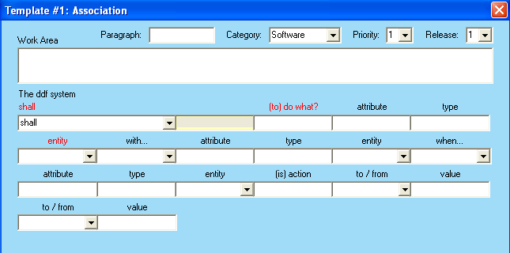

A)—1.5 marks
Functional requirements
Structural requirements
Technical requirements

B)—3.5 marks
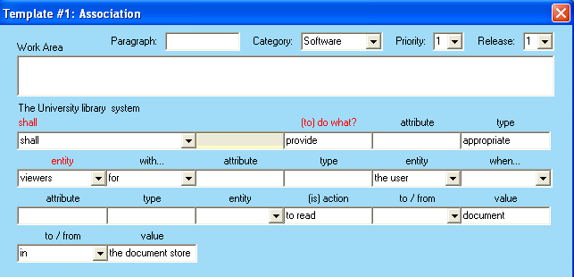

Question 6: : in Visual Studio .NET Debugger: (8 marks)
A) What are the variables that will be displayed in the following windows?
—1.5 marks
- Locals:
- Auto:
- This:
B) What is the difference between using the Immediate window to show variables values and using Watch window to do that? —1.5 marks

C) In Debug toolbar, what is the difference between using Step Over, Step Into and Step Out buttons in program debugging? —1.5 marks

D) Give a problem that we can use Break All button to solve it. —2 marks

E) What is the benefit of Call Stack window in program debugging? —1.5 marks
A) —1.5 marks
- Locals:
The Locals window displays the name and current value for all the variables that have block scope in the method containing the current statement

- Auto:
The Autos window displays the variables and values of the current statement and the previous statement

- This:
TheThis window displays data that has class scope for an object.

B)—1.5 marks

Use the Immediate window to show variables values one time (no update for each break). Placing variables inside the Watch window update variables values every time the program breaks. 24

C)—1.5 marks

The Step Over button executes one statement in a method, then pauses program execution at the following line. Using Step Over, if an evaluated statement invokes a method, the method is invoked, and execution stops at the next statement. Using Step Into, if a statement invokes a method, control transfers to the method for line-by-line. The Step Out button finishes executing the current method and returns control to the line that called the method.

D) —2 marks

When a program is executing, problems such as infinite loops usually can be interrupted by selecting Break All

E)—1.5 marks

The Call Stack window contains the program’s method call stack, which allows the programmer to determine the exact sequence of calls that lead to the current method and to examine calling methods on the stack.

Question 7: If you need to create Simple LAN modeling language using MetaEdit + 4.5 workbench where each LAN is a simple computer network that has a number of client computers (PC, Laptop) connected to only one server computer. Each server has speed and IP address, where each client computer has IP address. (8 marks)

- Draw GOPPRR(Graph, Object, Property, Port, Relationship, Role ) Figure for this modeling language (name each part of the graph). —2 marks

- To create Simple LAN modeling language using MetaEdit + 4.5 you need to use the following Dialog boxes : —6 marks
(Object tool, Property tool, Symbol Editor, Format, Relationship tool, Role tool, Graph tool with following tabs (Basics, Types, Binding, Subgraph and constraints).

In each step which of the above dialog boxes you will use, what are the values
that you will insert in the dialog and into which fields?

—2 marks

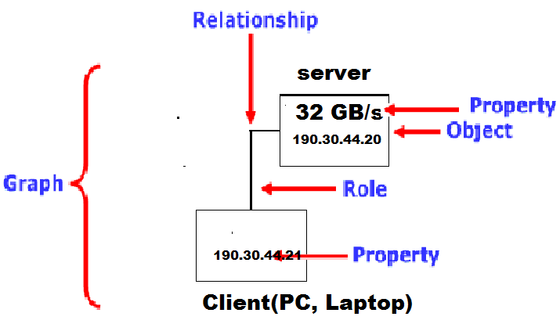

—6 marks

- Object tool➔ Name = Computer
- Property tool➔ Name = IP Address
- Object tool➔ Name = Server
- Property tool➔ Name = Speed

- Symbol Editor➔

- Format➔ Property = IP Address

- Format➔ Property = Speed

- Object tool➔ Name = Client

- Symbol Editor➔

- Format➔ Property = IP Address

- Relationship tool➔ Name = Simple LAN

- Role tool➔ Name = Server

- Role tool➔ Name = Client

- Graph tool➔ Basics tab ➔ Name = LAN

- Graph tool➔ Types tab ➔ Relationship = Simple LAN

- Graph tool➔ Types tab ➔ Roles = Server, Client

- Graph tool➔ Types tab ➔ Objects = Server, Client

- Graph tool➔ Binding tab ➔ Relationship = Simple LAN

- Graph tool➔ Binding tab ➔ Roles = Server, Client

- Graph tool➔ Binding tab ➔ Objects = Server, Client

III. Unfamiliar Problems Solving
Objectives: The aim of the questions in this part is to evaluate that you can make progress towards the solution of unfamiliar problems, and can set out reasoning and explanation in a clear and coherent manner.

Question 8: If you asked to create a model language for database that contains number of related tables, what is the ideal way to do that? (5 marks)

First Draw ER diagram for the relational database then convert the ER diagram to GOPPRR Graph and define all Objects, Properties, Ports, Relationships, Roles in GOPPRR from ER diagram. Then use MetaEdit + 4.5 to implement this model.

